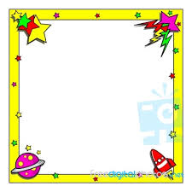
Twinkle twinkle little star
How I wonder what you are
Up above the world so high
Like a daimond in the sky
Twinkle twinkle little star
How I wonder what you are

